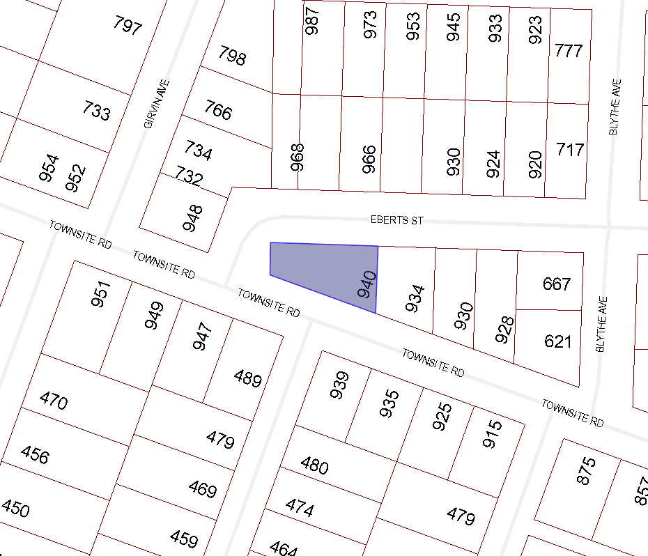

BOARD OF VARIANCE APPLICATION BOV00665

LOCATION MAP

CIVIC: 940 TOWNSITE ROAD

LEGAL: LOT 1, BLOCK 5, SECTION 1, DISTRICT LOT 96-G, NANAIMO DISTRICT, PLAN 2039

